Why Do They Do That???

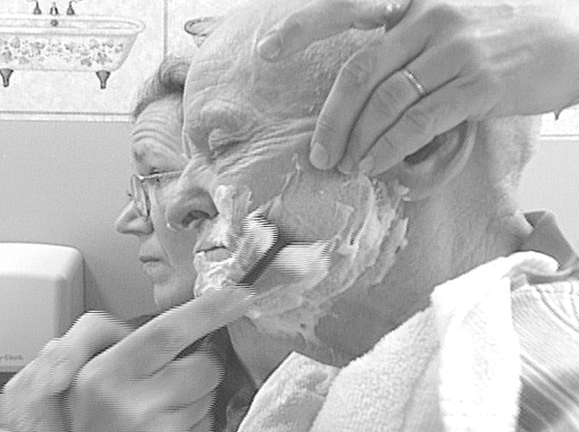

Understanding the Symptoms and Behaviors
AND
How to Help – When to Get Help!

Teepa Snow, MS, OTR/L, FAOTA
- Dementia Care & Training Specialist, Eastern NC Chapter, Alzheimer’s Association
- Counseling Associate, Duke University School of Nursing
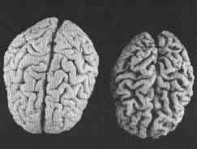
What is Dementia?

- It is NOT part of normal aging! It is a disease!
- It is more than just forgetfulness - which is part of normal aging
- It makes independent life impossible

Dementia
- is an umbrella term that includes many cognitive loss conditions
- includes some reversible conditions - so should be checked out carefully

Alzheimer's Disease -
- is the most common type of dementia
- is caused by damage to nerves in the brain and their eventual death
- has a expected progression with individual variations - about 8-12 years
- will get worse over time - we can't stop it!
- is a terminal disease - there is NO known cure at this time!

Vascular Dementia (Multi-Infarct) -
- is caused by damage to the blood supply to the nerves in the brain
- is spotty and not predictable
- may not change in severity for long periods, then there are sudden changes

Lewy Body Dementia -
- problems with movement – falls & stiffness
- visual hallucinations & nightmares
- fluctuations in performance – day/day

Frontal-Temporal Dementias -
- Problem behaviors – poor impulse control
- Difficulty with word finding
- Rapid changes in feelings and behaviors

Symptoms Common to Most Dementias… Over time…
- It affects a person's entire life…It causes the brain to shrink & stop working
- It steals memories - the most recent first, but eventually almost all…
- It steals your ability to use language … leaves you with some 'skills'
- It steals your ability to understand what others mean & say
- It steals reasoning and logic
- It robs you of relationships
- It makes even the 'familiar' seem odd and scary
- It steals your ability to care for yourself and move around safely
- It robs you of impulse control - takes away emotional and mood control

Drug Treatment for Alzheimers
- Drugs to improve chemicals in the brain so nerve activity might happen
- Drugs to treat depression
- Drugs to control distressing hallucinations, severe paranoia, or unprovoked violence
- No vaccines or cures…yet
- No way to stop the disease…yet

Prevention –
Have a good family history for staying alert and 'with it' – genetics do play a part
- Eat healthy & moderately (Heart-Smart)
- Exercise your body --- 100 minutes/wk ***
- Exercise your brain --- challenge yourself
- Eat fish --- 1 time a week
- Control your BP & sugar & weight
** consult your MD first

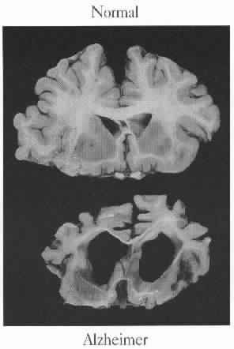
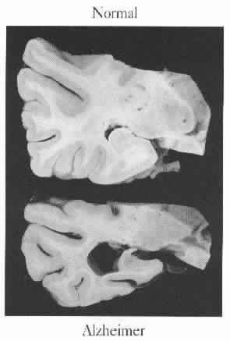
The ability to remember information…
The ability to use words and language…
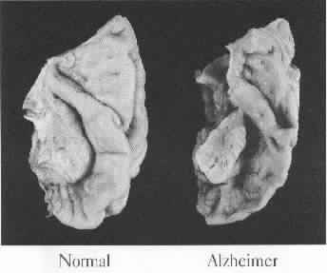
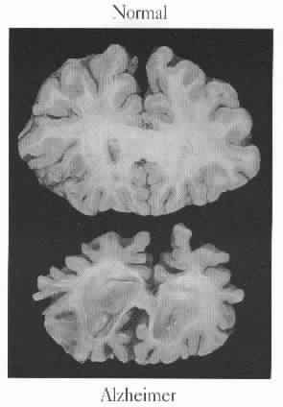
The ability to understand what is being said…
The ability to control your impulses, temper, & moods…
Reprinted with permission from: A Broken Brain. Dementia Education & Training Program , University of Alabama, 1995.

REALIZE …

It Takes TWO to Tango … or tangle…
- By managing your own behavior, actions, words & reactions you can change the outcome of an interaction.
- Being ‘right’ doesn’t necessarily translate into a good outcome for both of you
- Deciding to change your approach and behavior WILL REQUIRE you to stay alert and make choices… it is WORK
- It’s the relationship that is MOST critical NOT the outcome of one encounter

As part of the disease people with dementia ‘tend to’ develop typical patterns of speech, behavior, and routines. These people will also have skills and abilities that are lost while others are retained or preserved.

Typically Lost – can’t use Preserved – can or may use

Memory skills Memory skills

- immediate recall - long ago memories

- short term memory - emotional memories

- clarity of time and place - confabulation

- depth of categorical information - procedural memories

- relationships & specifics - awareness of familiar versus unfamiliar

Understanding skills Understanding skills

- interpretation of abstract meaning - ‘gets’ the concrete meaning

- early - misses ¼ words - picks out familiar or meaningful words

- later – misses ½ words - covers well

- subtle emotions, ‘unspoken’ agreements - facial expressions that are consistent

- at the end – most words with the message being sent

Language use skills Language use skills

- specific word finding - desire to communicate

- descriptive abilities - ability to use hands or actions to describe

- reading for content - reading aloud

- content of speech - rhythm of speech

- spoken communication - para-verbal communication (how you say it)

- words - music and song

- meaningful ‘yes’ and ‘no’ - automatic speech

- socially acceptable expressions of emotion - swearing, sex words, ‘socially unacceptable’ words

- verbal communication of needs and desires - non-verbal communication of needs and desires

Emotional & Impulse control skills Emotional & Impulse control skills

- ability to ‘demand’ respect - desire to be respected

- ability to limit or control emotions - ability to feel emotions and have needs

- ability to control impulsive speech - say what is on your mind – with errors

- ability to control impulsive actions - do what you want to do

- don’t act out when ‘pushed’ - sometimes, feel badly after its done

- ability to keep private thoughts and - sometimes, behaving differently in ‘public’

and actions in private places if cues are strong

Motor Skills & Sensory Processing Motor Skills & Sensory Processing

- at first very little as far as skills go - the movement patterns for pieces of tasks

- later – initiation or getting started - gross motor movements last longer than fine motor

- later – parts of tasks get left out/skipped - can often do the mechanics – BUT not safely or well

- mis-interprets sensory information - looks for stuff – seeks out things

- organized scanning is lost - mouth (lips, tongue), fingers and palms, soles of feet,

- visual field is restricted & genitalia or ‘private body parts’

- may become hypersensitive OR - recognize faces, voices – familiar from not familiar

hyposensitive to touch, sound, light…

Progression of the Disease – Levels of Cognitive Loss

Diamond - Level 5 – Early Loss – Running on Routine – Repeating Stories
Some word problems and loss of reasoning skill
Easily frustrated by changes in plans or routines
Seeks reassurance but resents take over
Still does well with personal care and activities
Tends to under or over estimate skills
Seeks out authority figures when upset or frustrated
Points out others’ errors, but doesn’t notice own behavior
May have some awareness – “Just not right” – might blame others or self
Can’t remember ‘new’ rules, locations, plans, discussions, facts

Emerald - Level 4 – Moderate Loss - Just Get It Done! – Wanting a Purpose and a Mission
Gets tasks done, but quality is getting to be a problem
Leaves out steps or makes errors and WON’T go back and fix it
Can help with lots of things – needs some guidance as they go
Likes models and samples – uses others’ actions to figure out what to do
Asks “what /where/when” LOTS
Can do personal care tasks with supervision & prompts – often refuses “help”
Still very social BUT content is limited and confusing at times
May try to ‘elope’ /leave to get to a ‘older’ familiar time or situation OR get away from ‘fighting’
Can’t remember what happened AND can mis-remember it – goes back in time, at times

Amber - Level 3 – Middle Loss - See It – Touch It – Take It – Taste It – Hunting & Gathering
Touches and handles almost anything that is visible
Does not recognize other’s ownership – takes things, invades space, gets ‘too close’
Can still walk around and go places – ‘gets into things’
Language is poor and comprehension very limited - does take turns
Responds to tone of voice, body language and facial expression
Loses the ability to use tools and utensils during this level
Does things because they feel good, look good, taste good – refuses if they don’t
Stops doing when it isn’t interesting anymore
Can often imitate you some – But not always aware of you as a person

Ruby - Level 2 – Severe Loss – Gross Automatic Action – Constant GO or Down & Out
Paces, walks, rocks, swings, hums, claps, pats, rubs….
Frequently ignores people and small objects
Doesn’t stay down long in any one place
Often not interested in/aware of food – significant weight loss expected at this level
Can grossly imitate big movements and actions
Generally enjoys rhythm and motion – music and dance
Doesn’t use individual fingers or tools (more eating with hands)
Either moves toward people and activity (feels like a shadow) or leaves busy, noisy places (ghost)
Chewing and swallowing problems are common – soft, ground, or puree food may be needed
May not talk much at all, understands demonstration better than gestures or words

Pearl - Level 1 – Profound Loss - Stuck in Glue – Immobile & Reflexive
Generally bed or chair bound – can’t move much on own
Often contracted with ‘high tone’ muscles - primitive reflexes reappear
Poor swallowing and eating
Still aware of movement and touch
Often sensitive to voice and noise - startles easily to sounds, touch, movement…
Difficulty with temperature regulation
Limited responsiveness at times
Moves face and lips a lot, may babble or repeatedly moan or yell
Give care in slow, rhythmic movements and use the flats of fingers and open palms
Keep your voice deep, slow, rhythmic and easy as you talk and give care

A Positive Physical Approach for Someone with Dementia
- Knock on door or table - to get attention if the person is not looking at you & get permission to enter or approach
- Wave and smile – look friendly and give the person a visual cue – make eye contact
- Call the person by name OR at least say “Hi!” – pause then start approaching or let the person come to you, if s/he likes to be in control
- Move your hand out from a wave to a greeting handshake position
- Approach the person from the front – come in within 45 degrees of the center
- Move slowly – one step/second, stand tall, don’t crouch down or lean in as you move toward the person
- Move toward the right side of the person and offer your hand - give the person time to look at your hand and reach for it, if s/he is doing something else – offer, don’t force
- Stand to the side of the person at arm’s length – respect personal space & be supportive not confrontational
- Shake hands with the person – make eye contact while shaking
- Slide your hand from a ‘shake’ position to hand-under-hand position – for safety, connection, and function
- Give your name & greet – “I’m (name). It’s good to see you!”
- Get to the person’s level to talk – sit, squat, or kneel if the person is seated and stand beside the person if s/he is standing
- NOW, deliver your message…

Approaching When The Person is DISTRESSED!
TWO CHANGES –
- Look concerned not too happy, if the person is upset
- Let the person move toward you, keeping your body turned to the side (supportive – not confrontational)
- After greeting… try one of two options…
  - “Sounds like you are (give an emotion or feeling that seems to be true)???”
  - Repeat the person’s words to you… If s/he said, “Where’s my mom?” you would say “You’re looking for your mom (pause)… tell me about your mom…” If the person said “I want to go home!”, you would say “You want to go home (pause)… Tell me about your home…”.

BASIC CARD CUES – WITH Dementia

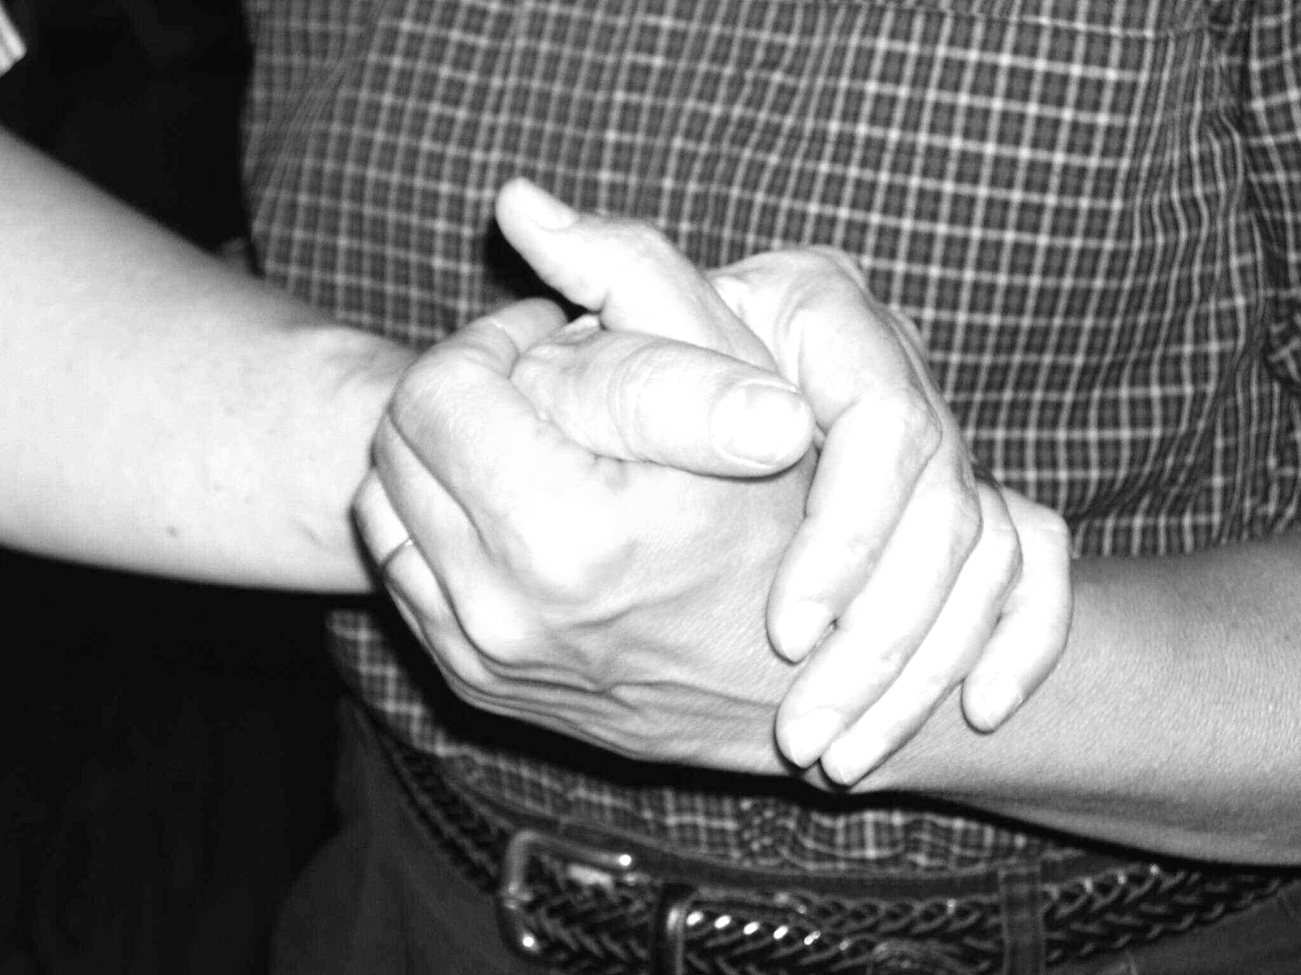
- Knock – Announce self
- Greet & Smile
- Move Slowly – Hand offered in ‘handshake’ position
- Move from the front to the side
- Greet with a handshake & your name
- Slide into hand-under-hand hold
- Get to the person’s level
- Be friendly -make a ‘nice’ comment or smile
- Give your message… simple, short, friendly

Communicating - Talking

First -
ALWAYS use the positive physical approach!

Then -
- Pay attention to the THREE ways you communicate -
1 - How you speak
- Tone of voice (friendly not bossy or critical)
- Pitch of voice (deep is better)
- Speed of speech ( slow and easy not pressured or fast)
2 - What you say
THREE basic reasons to talk to someone
- - To get the person to DO something (5 approaches to try)
1 - give a short, direct message about what is happening
2 - give simple choices about what the person can do
3 - ask the person to help you do something
4 - ask if the person will give it a try
5 - break down the task - give it one step at a time
** only ask “Are you ready to…” If you are willing to come back later **

2 - Just to have a friendly interaction - to talk to the person
- go slow - Go with Flow
- acknowledge emotions - "sounds like…, seems like…, I can see you are…"
- use familiar words or phrases (what the person uses)
- know who the person has been as a person what s/he values
- use familiar objects, pictures, actions to help & direct
- be prepared to have the same conversation over & over
- look interested & friendly
- be prepared for some emotional outbursts
- DON'T argue… - BUT don't let the person get into dangerous situations
REMEMBER - the person is doing the BEST that s/he can
AND GO with the FLOW!

- - Deal with the person's distress or frustration/anger
- Try to figure out what the person really NEEDS or WANTS
("It sounds like…" "It looks like…" "It seems like…" "You're feeling…")
- Use empathy not forced reality or lying
- Once the person is listening and responding to you THEN -
- Redirect his attention and actions to something that is OK OR
- Distract him with other things or activities you know he likes & values

Always BE CAREFUL about personal space and touch with the person especially when s/he is distressed or being forceful

3 - How you respond to the person
- use positive, friendly approval or praise (short, specific and sincere)
- offer your thanks and appreciation for his/her efforts
- laugh with him/her & appreciate attempts at humor & friendliness
- shake hands to start and end an interaction
- use touch - hugging, hand holding, comforting only IF the person wants it

If what you are doing is NOT working -
- STOP!
- BACK OFF - give the person some space and time
- Decide on what to do differently…
- Try Again!

Key Points About 'Who' the person Is….
- preferred name
- introvert or extrovert
- a planner or a doer
- a follower or a leader
- a 'detail' or a 'big picture' person
- work history - favorite and most hated jobs or parts of jobs
- family relationships and history - feelings about various family members
- social history - memberships and relationships to friends and groups
- leisure background - favorite activities & beliefs about fun, games, & free time
- previous daily routines and schedules
- personal care habits and preferences
- religious and spiritual needs and beliefs
- values and interests
- favorite topics, foods, places
- favorite music and songs - dislike of music or songs
- hot buttons & stressors
- behavior under stress
- what things help with stress?
- handedness
- level of cognitive impairment
- types of help that are useful

Having a Conversation

To Start Talking….. LISTEN!
First
–
- Recognize the person and their situation or feelings (don’t lie and don’t be cruel…)
- Use EMPATHY – “it looks like…”, “it sounds like….”, “it seems like…” OR “This is really hard”, “This doesn’t feel like the right place to be right now…”, “You really don’t like what is happening”…
Then
–
- If in early stages of the disease, gently offer ‘orienting’ information respecting what the person has said – NOT arguing reality…

- “It’s going to be a while before lunch…”, “The plan is for you to be here for tonight”, “ You are really missing your home, Tell me about where you come from…”

- If in the middle or later stages of the disease, figure out the meaning of the behavior or words ( repeat some of their words with a questioning tone to get started and when you aren’t sure what they mean or ‘where they are going with a conversation’ SLOW DOWN and then se…

- Redirection – same type of activity in a more acceptable manner, or with ‘safer’ materials, or in a safer space (Examples: cleaning out cabinets rather than the crash cart OR talking about her husband when they first got married versus why he is not here right now)

- Distraction – changing to a different but equally valued activity (Example: looking for her cat that no longer exists to helping to put away dishes from the dish drainer and clean up the dining room)

When having a conversation…

- use familiar phrases or words to help the person 'talk'
- use familiar objects or actions to give a focus for the interaction
- be prepared to have the SAME conversation over, and over, and over…..
- use your non-verbal interaction skills to show interest and engagement
- be prepared for unexpected emotional shifts and outbursts
( remember - it's part of the disease)
- don't try to correct the person… GO WITH THE FLOW! - use empathy not reality!
Communication - When Words Don’t Work Anymore…

Keys to Success:
- Watch movements & actions
- Watch facial expressions and eye movements
- Listen for changes in volume, frequency, and intensity of sounds or words
- Investigate & Check it out
- Meet the need

It’s all about Meeting Needs…
- Physical needs
- Emotional needs

Probable Needs:
Physical
- In pain or uncomfortable
- Thirsty or Hungry
- Need to pee or have a BM or already did & need help
- Constipated or impacted
- Tired
- Over stimulated or under stimulated
- Too hot or too cold
- Sick – medically ill – check for infections, physiological or physical causes

Emotional
- Afraid
- Lonely
- Bored
- Angry
- Excited
- In Pain

What Can You Do?
- Figure it out…Go thru the list
- Meet the need… Offer help that matches need
- Use visual cues more than verbal cues
- Use touch only after ‘permission’ is given

Connect – Visually, Verbally, Tactilely
Protect Yourself & the Person – use Hand Under Hand & Supportive Stance techniques
Reflect – copy expression/tone, repeat some key words, move with the person
Engage – LISTEN with your head, your heart, and your body
Respond – try to meet the unmet needs, offer comfort and connection

*** IF IT DOESN”T seem to be working – STOP, BACK OFF – and then TRY AGAIN – changing something in your efforts (visually, verbally, or through touch/physical contact)***

Types of Help - Using Your Senses

Visual -

Written Information - Schedules and Notes

Key Word Signs - locators & identifiers

Objects in View - familiar items to stimulate task performance

Gestures - pointing and movements

Demonstration - provide someone to imitate

Auditory -

Talking and Telling - give information, ask questions, provide choices

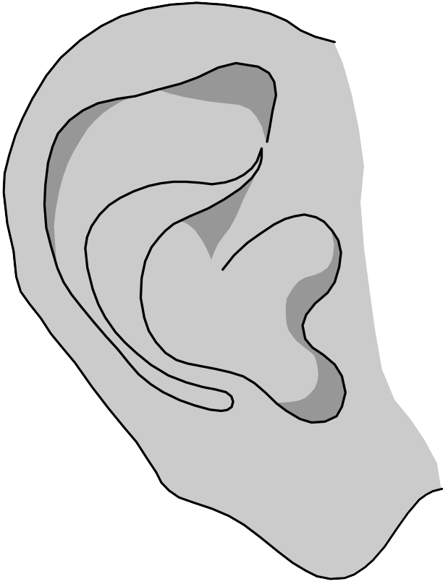
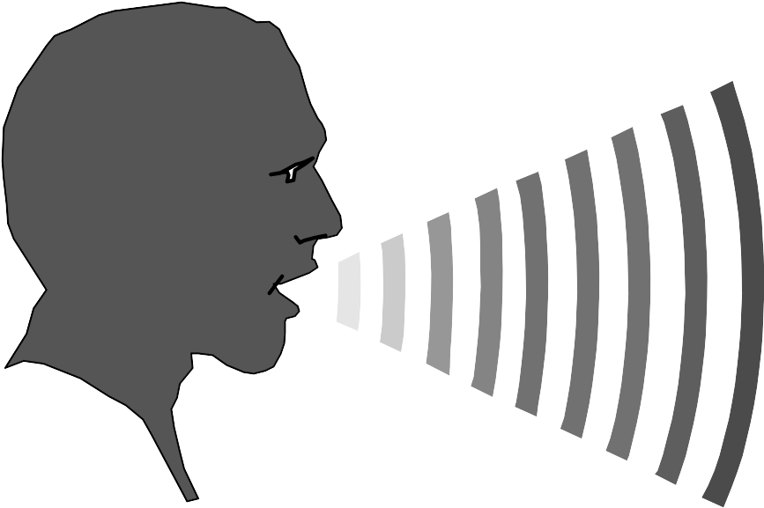
Breaking it Down - Step-by-Step Task Instructions

Using Simple Words and Phrases - Verbal Cues

Name Calling - Auditory Attention

Positive Feedback - praise, "yes", encouragement

Tactile - Touch -

Greeting & Comforting - handshakes, hugs, 'hand-holding'
Touch for Attention during tasks

Tactile Guidance - lead through 'once' to get the feel

Hand-Under-Hand Guidance - palm to palm contact

Hand-Under-Hand Assistance - physical help

Dependent Care - doing for & to the person

Personal History
Areas to Explore | What Did You Find Out?

Preferred Name

Preferred Hand

Living Situations & history

(where are you from today & originally, who do & did you live with, what type places did you live in (house, apt, farm…)

Marriage history & status

(who’s involved, has been involved, and how do you feel about them?)

Family history & membership

(who’s who and how do you feel about them? Think about several generations….)

Work history

(what jobs have you had in your life? How did you feel about them? What are some jobs you would have loved to do, but never did? )

Leisure history

(what do and did you do for fun and in your spare time? How do you feel about ‘having fun’? What would you like to do if you had the money? time? Skill? )

Spiritual history

(what religion do you and did you follow, how involved are you and were you, and how important is it to you? How do you feel about other religions?)

Personal care practices & history

(eating habits, sleeping habits, grooming & bathing habits…)

Time Use History

(schedules & routines…. When do you and would you like to do things?)

Important Life Events

(what are some things that were very important to or happened to you? Do others know about these events?)

Hot Buttons

(what are things/activities /topics/ actions that really tend to upset you?)

Chill Pills

(What helps you calm down, what do you do when you are upset?)

Alzheimer’s
Disease

Early onset
Normal onset

Vascular (Multi-infarct)
Dementias
Lewy Body Dementia
DEMENTIA

Fronto-
Temporal Lobe Dementias
Other Dementias
Metabolic diseases
Drug toxicity
White matter diseases
Mass effects
Depression
Infections
Parkinson’s
Alzheimer’s
- New info lost
- Recent memory worse
- Problems finding words
- Mis-speaks
- More impulsive or indecisive
- Gets lost
- Notice changes over 6 months – 1 year
Vascular
- Sudden changes
- Picture varies by person
- Can have bounce back & bad days
- Judgment and behavior ‘not the same’
- Spotty losses
- Emotional &energy shifts

Lewy Body
- Movement problems - Falls
- Visual Hallucinations
- Fine motor problems – hands & swallowing
- Episodes of rigidity & syncopy
- Nightmares
- Fluctuations in abilities
- Drug responses can be extreme & strange

Frontal-Temporal
- Many types
- Frontal – impulse and behavior control loss
  - Says unexpected, rude, mean, odd things to others
  - Dis-inhibited – food, drink, sex, emotions, actions
- Temporal – language loss
  - Can’t speak or get words out
  - Can’t understand what is said, sound fluent – nonsense words

Is this a Problem Behavior that NEEDS to be fixed?

Does the behavior put someone at RISK?
This is not really a PROBLEM behavior for the person with dementia.
It may be irritating or embarrassing for the caregiver, but it is really a…
‘SO WHAT’ behavior

Learn to let it go!
Leave it alone!
Don’t sweat the small stuff!
It’s time to PROBLEM-SOLVE!
NO
YES
Describe the behavior in detail---
Where does it happen?
When does it happen?
Who is involved?
How does it start? Stop?
What is said? done?
What makes it worse? better?

BRAINSTORM with the Puzzle Pieces
Answer these questions---
Could the level of dementia explain some of this behavior?
Could how the person was approached or helped have some impact?
Does the person have other medical or psychiatric conditions that might be active?
Could personal history (work, leisure, family, religion, personality, routines…) play a role?
Could the environment or cues in it be causing some of the trouble?
Could the time of day or personal habits be a factor?
RETHINK & Problem solve again!
NO
YES
CELEBRATE!
Are things better?
1st

Then
Come up with a PLAN of ACTION!
- decide on what to do
- decide who will do what
- decide how to do it
- decide when to start it & when to look again
- set a goal
- DO IT!

